Goods Lift |  | 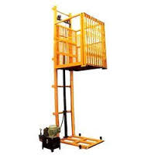
Make | NIHVA
Capacity in KG | 500 up to 2000
Platform Width in MM | Customized
Platform Length in MM | Customized
Operation Control | Through Panel
Power Pack | Hydraulic
Drive Type | Direct by electric Motor
Motor Make | Crompton
Pump Design Flow (LPM) | 2.5
Pump Type | Gear
Safety Valve Set Pressure (Kg/Sq. Cm) | 120
Volume of Oil Receiver (Liter) | 7
Power Supply | 3 Phase
Clear Pit Dimensions (W x L x D) MM | 2080 X 2780 X 485 (Option)
Color | Golden Yellow & Black
Fixing | On Floor / Within Pit
Railing / Cabin Type | Optional
Lifting Speed (Mtr. /Min.) | 3
Lowering Speed (Mtr. /Min.) | 1.5 / 2
Mast Type | Single / Double
Type of Enclosure | Optional
Outside Enclosure Required | Optional
Gate | Hinged / Collapsible
Gate Clear Width in MM | Customized
Gate Clear Height in MM | Customized

